# 2. How to do OR queries in Django ORM?

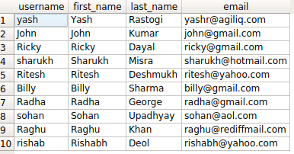

If you are using django.contrib.auth, you will have a table called auth_user. It will have fields as username, first_name, last_name and more.

A common requirement is performing OR filtering with two ore more conditions. Say you want find all users with firstname starting with ‘R’ and last_name starting with ‘D’.

Django provides two options.

* queryset_1 | queryset_2
* filter(Q(<condition_1>)|Q(<condition_2>)

# 2.1. The query in detail

The SQL query for the above condition will look something like

SELECT username, first_name, last_name, email FROM auth_user WHERE first_name LIKE 'R%' OR last_name LIKE 'D%';

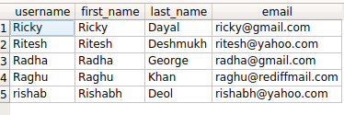

Similarly our ORM query would look like

>>> queryset = User.objects.filter(

first_name__startswith='R') | User.objects.filter( last_name__startswith='D')

>>> queryset

<QuerySet [<User: Ricky>, <User: Ritesh>, <User: Radha>, <User: Raghu>, <User: rishab>]>

You can also look at the generated query.

In [5]: str(queryset.query)

Out[5]: 'SELECT "auth_user"."id", "auth_user"."password", "auth_user"."last_login",

"auth_user"."is_superuser", "auth_user"."username", "auth_user"."first_name",

"auth_user"."last_name", "auth_user"."email", "auth_user"."is_staff",

"auth_user"."is_active", "auth_user"."date_joined" FROM "auth_user"

WHERE ("auth_user"."first_name"::text LIKE R% OR "auth_user"."last_name"::text LIKE D%)'

Alternatively, you can use the Q objects.

**from** django.db.models **import** Q

qs = User.objects.filter(Q(first_name__startswith='R')|Q(last_name__startswith='D'))

If you look at the generated query, the result is exactly the same

In [9]: str(qs.query)

Out[9]: 'SELECT "auth_user"."id", "auth_user"."password", "auth_user"."last_login",

"auth_user"."is_superuser", "auth_user"."username", "auth_user"."first_name",

"auth_user"."last_name", "auth_user"."email", "auth_user"."is_staff",

"auth_user"."is_active", "auth_user"."date_joined" FROM "auth_user"

WHERE ("auth_user"."first_name"::text LIKE R% OR "auth_user"."last_name"::text LIKE D%)'